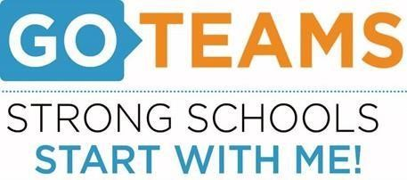
School | Date | Time | Location
BEST Academy (6-12) | 2/8/22 | 5:00pm | Zoom Call
Notice Prepared By: Dr. Timothy Jones Date Posted: February 8, 2022 Revised: 2/7/22

Meeting Agenda
(Agenda may be amended)
This meeting will allow for Public Comment
Join Zoom Meeting: https://atlantapublicschools-us.zoom.us/j/82681561524?pwd=WVh1TlViejE1aHhtNC8xU0NjR2R3Zz09
- START Recording
- Call to Order:
- Roll Call; Establish Quorum
- Action Items
  - Approval of Agenda
  - Approval of Previous Meeting Minutes -
C. Budget SY 22-23
- Strategic Plan Review -
- Discussion Items - Budget
Strategic Plan
- Information Items -
A. Test Talk (Dr. Johnson and Ms. Kelley)
B. Anti-Gun Violence Initiative – Dr. Jones
C. TEM Update
D. Winter Break February 17-21

- Public Comments
- Announcements
  - Next meeting March 10, 2022
- Adjournment

